Article 16 — The Decision Layer
Michal Doroszewski

The Vending Machine That Thinks Too Much
You walk up to a vending machine. You press B7 for pretzels. The machine pauses, thinks, and displays “Evaluating…” which is already a bad sign. Then it says “Checking inventory.” Then “Verifying payment method.” Then “Assessing risk.” Then “Location mismatch.” You haven’t moved. You haven’t changed. You’re still standing in front of the same machine with the same dollar bill. You press B7 again. Now it says “Posture unknown.” You press the coin return. It says “Action denied.”
You step back. Someone else walks up, presses C3, and instantly gets a granola bar.
You try again. “Signal incomplete.” You try again. “Session expired.” You try again. “Decision deferred.”
The vending machine isn’t broken. It’s indecisive. It has inputs. It has logic. It has a job. But it cannot reconcile the signals it receives with the rules it’s supposed to enforce. So it stalls. It contradicts itself. It denies. It resets. It behaves like a system that was never taught how to decide.
That is the Decision Problem — the architectural moment when the system must choose an outcome, but the truth it needs to choose never arrives intact.

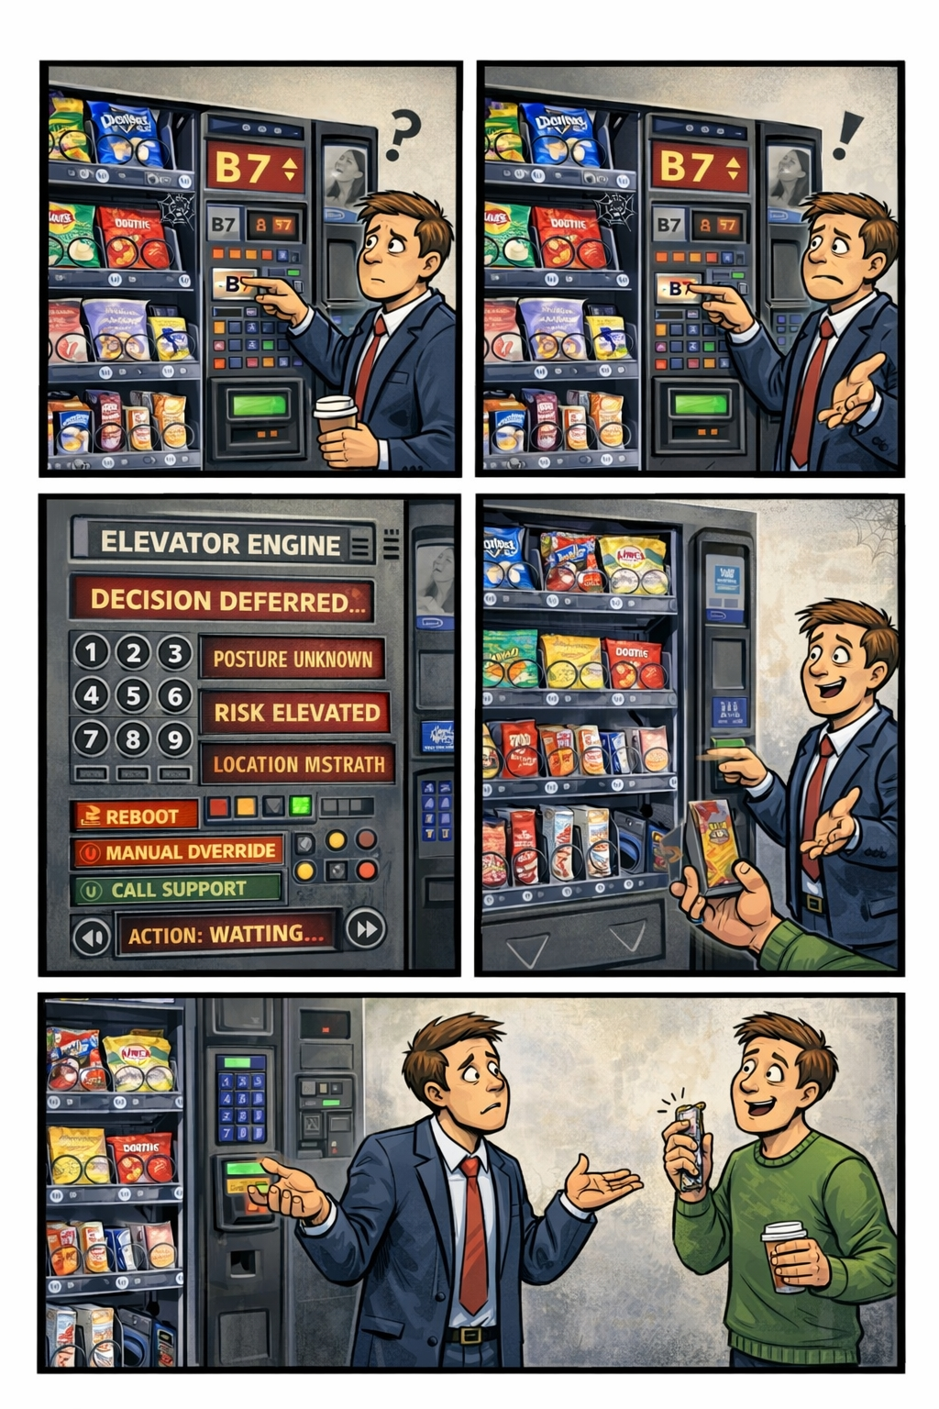

Decisions Are the Sixth Layer of Modernization
Visibility shows what’s happening. Continuity stabilizes identity. Control defines what the system is allowed to do. Signals carry the truth. Evaluation interprets the truth. But the Decision Layer is where the system finally acts. It is the moment where all the upstream layers either converge into clarity or collapse into noise.
A modern identity platform must make real‑time decisions about access, trust, posture, risk, and compliance. These decisions must be deterministic, consistent, and explainable. When they are not, the system does not fail — it improvises. Improvisation is the enemy of modernization. A system that cannot decide cannot enforce. A system that cannot enforce cannot protect. A system that cannot protect cannot modernize.

Why Decisions Collapse in GCC‑Moderate
The FedRAMP Moderate boundary was built for static policy, not dynamic decision engines. It filters signals, delays timing, distorts context, and fragments identity state. The Decision Layer receives partial truth and is expected to produce a definitive outcome. It sees the user but not the session. It sees the device but not the posture. It sees the risk but not the location. It sees the request but not the refresh. The system is not denying the user. It is denying the uncertainty.
A decision engine cannot choose when the architecture withholds the truth required to choose.

Headquarters and Field Offices Live in Different Decision Universes
At headquarters, decisions are fast and consistent. Signals arrive intact. Context is preserved. Evaluation is complete. The decision engine behaves like a decision engine.
In field offices, decisions are slow and contradictory. Signals arrive late. Context is distorted. Evaluation is partial. The decision engine behaves like a coin toss.
The same user, same device, same request — different outcome. The architecture creates two realities, and the system enforces both.

Why Decision Failures Are Misdiagnosed
When the Decision Layer collapses, every team sees a different symptom. Security sees inconsistent enforcement. Identity sees token churn. Network sees latency spikes. Operations sees region drift. Users see random denials. Everyone is correct. Everyone is wrong. The failure is architectural. The system cannot decide because the truth required to decide never arrives intact.

The Comic Moment
Comic placeholder: A giant “Decision Engine” panel with oversized buttons labeled ALLOW, DENY, MAYBE, TRY AGAIN, CHECK LEGACY SYSTEM, and ASK BOB. The system proudly displays “Decision: CONFUSED” while an operator flips a coin and shrugs.

The Root of the Decision Problem
The Decision Problem is not caused by bad policy, misconfigured rules, incorrect groups, or user error. It is caused by an architecture that cannot reliably deliver the truth required for deterministic decisions. The boundary filters the truth. The WAN delays the truth. The inspection layers distort the truth. The region model mislabels the truth. The identity platform receives partial truth. A system cannot decide with partial truth. A system cannot enforce inside a fog.

The Only Way Forward
The Decision Layer must be restored. Signals must arrive intact. Timing must be preserved. Identity state must be authoritative. Evaluation must be complete. Policy logic must receive the full truth. Only then can decisions be consistent. Only then can enforcement be predictable. Only then can modernization move forward without contradiction.

Disclaimer
Not all agencies will experience the issues described in this article. These behaviors occur primarily in architectures where cloud identity, Conditional Access, and real‑time decision engines depend on signals that traverse GCC‑Moderate boundaries, WAN inspection layers, or region‑variable paths. Agencies with direct identity paths, stable network topologies, or on‑premises authentication may see different outcomes. These observations reflect common patterns in GCC‑Moderate cloud environments, not universal conditions.

About the Author
Michal Doroszewski is a technology strategist focused on cloud architecture, identity platforms, and federal modernization. He writes about the structural and architectural forces that shape government IT, translating complex technical constraints into clear, accessible narratives for leaders and practitioners.

